**CSci 384: Artificial Intelligence Spring, 2018**

**Instructor: Dr. M. E. Kim Date: March 29th , 2018**

**Due: 5:00 PM, April 6th, 2018 (Fri.)**

**Home Assignment 3: FOL (200 points)**

**Q1.** [10] Decide each sentence is valid (necessarily true). Justify your answer.

1. (∃*x x* = *x*) → (∀*y* ∃ *z* *y* = *z*)
   1. **False, the first statement has no relation to the second. If there exists an x=x, then for all of y there exists a z that is equal to y.**
2. ∀*x* Smart(*x*) ∨ (*x* = *x*)
   1. **True, x is smart, or x is equal to all other x’s.**

**Q2**.[40] For the given English sentence, write them in First-Order Logical sentence which is both syntactically valid and express the meaning correct, using the following predicates and function.

Predicates: In(*x, y*) – A country *x* is in the region *y*.

Borders(*x, y*) - *x* borders *y*.

Person(*x*) - *x* is a person.

HasSSN(*x, y*) - *x* has a social security number *y*.

Occupation(*p, o*) – Person *p* has occupation *o*.

Customer(*p, q*) - Person *p* is a customer of person *q*.

Born(*x, y*) - Person *x* was born in the country *y*.

Parent(*x, y*) - Person *x* is a parent of *y*.

Citizen(*x, y, z*) - Person *x* is a citizen of a country y by *z*.

Resident(*x, y*) - Person *x* is a resident of country *y*.

Constant: SouthAmerica, Europe, UK, Birth, Doctor, Lawyer.

1. [10] No region in South America borders any region in Europe.
   1. **Borders(­­­­­­­­­­­­­­­not south America, Europe)**
2. [10] There is a lawyer all of whose customers are doctors.
   1. **Occupation(Lawyer, Doctors)**
3. [10] No two people have the same social security number.
   1. **HasSSN(x, y), HasSSN(z, not y)**
4. [10] A person born in the UK, each of whose parents is a UK citizen or a UK resident, is a UK citizen by birth.
   1. **Born(Person, Citizen(person, UK, Citizen(Parent(x ˅ y, person), UK, z) ˅ Resident(Parent(x ˅ y, Person)))**

**Q3.** [10] Translate the given FOL sentence into good and natural English **without using variables *x’*s or *y’*s.**

∀ *x, y, l* SpeaksLanguage(*x, l*) ∧ SpeaksLanguage(*y, l*) ⇒ Understands(*x, y*) ∧ Understands(*y, x*)

**If person one speaks a language, and person two speaks the same language, then person one will understand what person two is saying and person two will understand what person one is saying.**

**Q4.** [12] Find the **MGU** (most general unifier) in each pair of sentence below or justify why unification is not possible.

1. [6] Knows(Father(*y*), *y*), Knows(*x, x*)
   1. **MGU = {y/Father, x/x)**
2. [6] Wines(*x, y*) vs. Wines(*y, x*)
   1. **MGU = {x/y, y/x}**

**Q5.** [18] Write down the following sentences in the 1st -order logical representations, suitable for their use with ***Generalized Modus Ponens***, i.e. in Horn clauses. Do NOT convert them in CNF.

1. Horses, cows, and pigs are mammals.
   1. **Horses(x)** **∧ Cows(x) ∧ Pigs(x) 🡪 mammals(x)**
2. An offspring of a horse is a horse.
   1. **Offspring(Horse, Horse)**
3. Bluebeard is a horse.
   1. **Horse(bluebeard)**
4. Bluebeard is Charlie’s parent.
   1. **Parent(bluebeard, Charlie)**
5. Offspring and parent are inverse relations.
   1. **¬ Parent 🡪 Offspring**
6. Every mammal has a parent.
   1. ∀ **x parent(mammal, x)**

**Q6.** [20 pt] From the sentences you wrote in Q8, answer the following question using a ***backward-chaining algorithm***.

1. [10] Draw the proof tree generated by a backward chaining algorithm for the query

∃ *h,*  *Horse(h),* where clauses are matched in the order given.

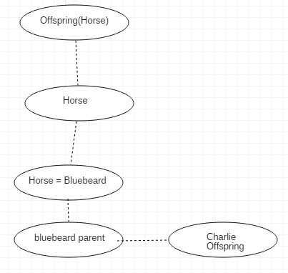

1. [5] What do you notice about this domain?
   1. This does not take into account for the cows and pigs.
2. [5] How many solutions for *h* actually follow from your sentences?
   1. 2, True or False.

**Q7.** [30] From ”Horses are animals”, it follows that ”The head of a horse is the head of an animal.”.

Demonstrate that this inference is valid by carrying out the following steps:

1. [10] Translate the premise and the conclusion into the language of 1st -order logic. Use three predicates:

*HeadOf(h,x)* - meaning *h* is the head of *x*.

*Horse(x)*

*Animal(x)*

Horse(x) 🡪 Animal(x)

HeadOf(Horse(x)) 🡪 HeadOf(Animal(x))

1. [10] Negate the conclusion, and convert the premise and the negated conclusion into conjunctive normal form (CNF).
   1. ¬HeadOf(Horse(x)) ∨ HeadOf(Animal(x))
2. [10] Use ***resolution*** to show that the conclusion follows from the premise. Draw the *proof tree of resolution,* showing the *substitutions*; see Figure 9.11-12 in the textbook.

**Q8.** [40] Given sentences (A – E) below,

* 1. All great chefs are French.
  2. All Frenches enjoy good food.
  3. Paul or Sophie is a great chef.
  4. Paul is not a great chef.
  5. Query: Who enjoys good food?

1. [10] write them in their 1st -order logical representations using the following predicates and constants:
   1. ∀ x GC(x) = F(x)
   2. ∀ x F(x) = EF(x)
   3. GC( Paul ∨ Sophie)
   4. GC(¬Paul)
   5. ASKVARS(KB, EF(x))

Predicates: GC – great chef(s), F – French, EF – enjoy good food,

Constants: Paul, Sophie

1. [10] Answer the query by ***forward chaining*** method. Draw the proof trees showing the substitutions step by step. Refer to the slide #23 - #25.
   1. ∀ x GC(x, y) ∧ F(y) 🡪 EF(x)
   2. 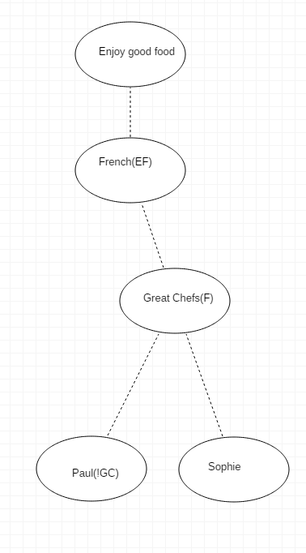
2. [10] Convert the sentences in 1) to the definite clauses in CNF, suitable for Knowledge_Base through Skolemization, etc. if necessary. Refer to the slide #42.
   1. **From ∃ x GC(x, F). GC(chef, F)**
   2. **From ∃ x F(x, EF). F(French, EF)**
   3. **GC( Paul ∨ Sophie)**
   4. **GC(¬Paul)**
   5. **ASKVARS(KB, EF(chef))**
3. [10] By applying ***resolution****,* answer the query. Show the steps of proof by drawing the resolution tree. Refer to the figure in slide #43 of Chap. 9.

**Q. EF(Sophie)? ¬EF(Paul)**

**Q9.** [20] Suppose that the sentence A in Q11 is changed to:

A1. *Some* great chefs are French.

1. [6] Write it in the FOL sentence.
   1. **∃ x GC(x) ∧ F(x)**
2. [6] Convert 1) to the definite clause in CNF, suitable for Knowledge_Base through Skolemization, etc. if necessary.
   1. **∃ x GC(x) ∧ F(x) = False**
3. [8] Prove how the same query can be answered (or not). Justify your answer step by step.